Anomaly Detection Techniques for Financial Fraud in Credit Card Transactions Using Hybrid Deep Learning Model

Ashma Ul Husna
Department of Computer Science
American International University- Bangladesh
Dhaka, Bangladesh
ashmaulhusna530@gmail.com
Rashida Begum Lima
Department of Computer Science
American International University- Bangladesh
Dhaka, Bangladesh
rashidalima881@gmail.com

Abstract— The modern world is evolving day by day in the economic sector, which has made our lives easier with many inventions. Electronic payment is one of the inventions in financial transactions that makes people trade money products and services easier at any time for daily activities. Several machine learning (ML) methods have been introduced to reduce this fraud over time. But it lacks modern technology, which is highly used and demanded by people. Many genetic algorithms and hybrid model-based systems have been proposed till now to detect credit card fraud transactions. Some of them are not capable enough to find a proper solution in terms of real-time and efficiency. Bridging the gap between feature selection, imbalance classification is time-consuming, so it's difficult to use for real-time fraud detection. As fraud detection is a critical issue, real-time detection is an important part of ensuring the minimum loss. A lightweight deep learning model is proposed here that utilizes the computation power of XGBoost which is more flexible than traditional deep learning models and also utilizes transformers, which are known for their ability to extract meaningful features and model sequences effectively from datasets. The proposed approach got an accuracy of .9987. This model is a lightweight deep learning model that ensures efficiencies and real-time detection in a minimum amount of time, providing a solution to this real-world issue.

Keywords: Credit Card, Fraud Detection, Feature Extraction, XGBoost, Transformer Encoder

INTRODUCTION
In recent years, due to advancements in the technological site and development the electronics several funding methods are the most common option for electronic payments (e-payments) [1]. In the present view, competitive financial sector e-payment systems are mostly preferred for the use of credit cards [2]. Businesses benefit from electronic payments because they provide reduced transaction costs, secure transactions, faster processing speeds, and time and resource savings, among other advantages [3]. In research of 2021, 121 countries based on it was found that credit card was 22.26 percent of the number of people [4]. At the time, increasing the number of fraudulent transactions. Global connectivity and rapid digitalization, a major problems in credit card fraud detection, that just not individuals but also businesses and financial institutions. According to a statistic, fraudulent card payments reached 32 billion dollars in 2021 and are expected to increase by more than 10 billion dollars between 2022 and 2028 [5]. As this is an increasing issue, an efficient credit card fraud detection system is needed to reduce fraudulent transactions.
Many papers have researched this fraud detection technique to provide a solution. Several machine learning (ML) methods have been introduced to reduce this fraud over time. But it lacks modern technology, which is highly used and demanded by people. Internet of Things and big data due to high dimensions with their enormous datasets. These datasets have some features that might be less significant to the response variable. Feature extraction for highly unbalanced data, for machine learning could increase the complexity and lead to overfitting of the model [6].
Real-time fraud detection techniques aim to identify the most important part needed to develop a well-performing machine learning model [7], ensuring improved classification, and creating a lightweight model are utilizes the computational complexity by removing irrelevant and real-time features. As fraud detection is case-sensitive issue, so creating a lightweight model utilizes the computational power of XGBoost which is more flexible that traditional deep learning model. And also utilize transformer, which are known as their ability to extract meaningful features and model sequences effectively from datasets. Lightweight models are more flexible than traditional deep learning models since they may be adjusted to meet specific use cases [8].
However, transformer encoder methods use a hybrid feature selection model which is Self-attention and Feedforward network, to make the model more accurate in the complex pattern analysis. For capturing the relationships between the features, how they react with each other is calculated in the self-attention process. Transformers are known for their ability to solve complex scenarios and patterns. Transformer helps in feature extraction without complexing the algorithm. Moreover, the transformer-encoder model is lightweight, so it can be used in real-life cases like fraud detection in credit card transactions. Additionally, this model can analyze and detect trends in time-series data, which gives extra advantages in the detection of anomalies in financial sectors like credit card fraud. Meanwhile, as a classification method, the XGBoost classifier is used. The XGBoost classifier is the most lightweight technique in terms of classification and is also able to give good accuracy for real-time applications. The Transformer Encoder eliminates unnecessary complexity and is focused only on the essential features and patterns that are required to make the system more efficient and detect fraud in real-time transaction scenarios. The Transformer Encoder component is lightweight compared to full transformer models (BERT). Unlike sequential models like RNNs or LSTMs, the transformer’s self-attention mechanism processes all features at once parallelly, which reduces computation time. It also saves computational resources by minimizing the feature space provided to the classifier through the extraction of high-quality features. Additionally, for structured data, XGBoost works effectively. It iteratively increases classification accuracy with minimal overhead by using an enhancement strategy. Also, for real-time applications, it preserves computational efficiency.
As fraud detection is a challenging issue in real time scenario and many methods fail to provide solution to this, this research work focuses on ensuring best solution. The limitations of existing researches are highlighted here and used algorithms are discussed.

Literature Review
In recent days, Machine Learning (ML) algorithms can be applied for credit card fraud detection, classifying incoming transactions based on previous transactions as legitimate or fraudulent [9]. The combination of nature-inspired learning and ML algorithms results in both of these methods being more robust hybrid model defects for credit card fraud [10]. In 2018, Kuldeep Randhawa et. Al. proposed by Majority Voting that AdaBoost models are being used for credit card fraud detection [11]. According to the author, a case-sensitive problem in financial services occurs credit card fraud. Every year, credit card fraud causes losses of billions of dollars. It lacks research study on real-world analysis owing to credit card data to issues of confidentiality. As per the author, detect credit card fraud using machine learning algorithms. Firstly, they used the standard model, then used hybrid methods, which are majority voting and AdaBoost. Analyze a data set of real-world credit cards from a financial institution where a noisy data sample is added to the robustness of further accessing the algorithms. These results show that all accuracy rates are 99%, and the experiment of SVM at 95.5% and AdaBoost helps improve the rate of fraud detection that is achieved by LIR, i.e., from 7.4% to 94.1% accuracy achieved in fraud cases detecting credit cards.
Other recent methods by Karthik et. Al. [12] Credit card fraud detection to solve the imbalance class problem proposed a hybrid ensemble. The study achieved superior performance comparing the individual classifiers using, respectively, adapting boosting (AdaBoost), random forest, bagging methods, and combined boosting. Businesses use machine learning technologies, such as neural networks, to detect credit card fraud. The experiment result shows the Matthews correlation coefficient, respectively, from the state-of-the-art techniques with a detection rate of 0.6650 and an accuracy of 99.18%, respectively. They proposed a CCFD method for Mienye and Sun [13] using a hybrid feature selection approach by learning algorithms of extreme learning machines (ELM), genetic algorithms, and information gain. Tackle the imbalance problem of class and improve performance leading to classification, employed in the study of genetic algorithms fitness function, which was implemented by geometric means. The experiment results achieved sensitivity and specificity of 0.997 and 0.994, respectively, outperforming other baseline techniques and methods in the recent literature.
In recent years, deep learning technology has had strong capabilities in many fields; it has significantly developed to promote the financial industry, and at the same time, it can bring new ideas to how to detect financial fraud. In 2016, Fu et al. [14] worked on a fraud detection CNN-based network that implements the intrinsic patterns from a level of data to identify the fraudulent behavior and whether every transaction sample has fraudulent behavior. Saia et al. [15] worked on analyzing the financial fraud detection issue and the heterogeneity of frequency domain to credit card data to obtain more effective information to represent fraud detection. In 2019, Fiore et al. [16] worked on the imbalance classification problem for financial fraud detection data, and this paper uses GAN to generate minority class samples that help to train a better classifier. In 2022, Esenogho et al. [17] worked with hybrid data resampling techniques and also used integrated learning to conduct LSTM and AdaBoost robust credit card fraud detection. The technique achieved an accuracy of 98.40% and a precision of 97.34%.
A 2024 study by El Kafhali, Tayebi, and Sulimani is titled "Advanced Deep Learning Techniques for Fraudulent Credit Card Transactions Detection" and was able to reach state-of-the-art results [18]. The experiment results show that RNN outperformed LSTM and ANN with an accuracy of 95.93% and an AUC of 97.67%. RNN also achieved perfect precision during specific iterations of Bayesian-optimized hyperparameter tuning. This work promises the great potential of RNN in fraud detection while paying more attention to the practical challenges of real-world deployment.
The authors of [19] deal with an ensemble deep learning model for credit card fraud detection. The ensemble model combines both LSTM and GRU as base learners and an MLP as a meta-learner in a stacking framework. The ensemble model applied with these strengths of the neural networks performs well with a 90.5% sensitivity, better than that of the traditional classifiers with 80.2% random forests and 77.5% AdaBoost. The algorithm used the SMOTE-ENN technique, which is the one for boosting minority class representation as well as eliminating noise. It carried PCA over the more than 283,000 transactions in data for privacy preservation purposes. The proposed approach has several drawbacks: lack of diversity of base models and no study on feature importance.

Identifying Research Gap
The authors of the selected paper used hybrid feature-selection methods like genetic algorithms (GA). The genetic algorithm needs to perform multiple iterations to find the solution. Also, the genetic algorithm is time-consuming because it can take much time to converge [20]. The computationally demanding nature of the genetic algorithm makes it difficult to use for real-time fraud detection. A computationally efficient architecture can be more useful for credit card transaction fraud detection.
The authors work with a Genetic Algorithm (GA) wrapper using the Extreme Learning Machine (ELM). However, it does not utilize advanced architectures like transformers, which are known for their ability to extract meaningful features and model sequences effectively from datasets. By using a hybrid model with advanced features, it could be more robust and precise in fraud detection because of its learning techniques.
The paper focuses on traditional ML methods like Random Forest, SVM, and ELM, but it does not evaluate or compare performance against modern lightweight models or deep learning techniques. Lightweight models are more flexible than traditional deep learning models since they may be adjusted to meet specific use cases [21].

Justification of Research Gap
In the selected paper, the scalability and Real-time application are mainly focused on Genetic Algorithms (GA) and Extreme Learning Machines (ELM) such as the hybrid feature-selection approach. By bridging the gap in feature selection and imbalanced classification, this study can essentially progress the possible arrangement of fraud detection systems. This study focuses on these gaps, in particular, creating a lightweight demonstration that utilizes the computational power of XGBoost and the highlight extraction control of Transformer Encoders to optimize for speed and efficiency. The hybrid model used by using GA and ELM, might not be computationally efficient or scalable enough for real-time detection in high-volume transaction scenarios for fraud detection. The Transformer Encoder and XGBoost should be able to meet these requirements.
Combining emerging technologies by incorporating a Transformer Encoder into fraud detection frameworks, the research puts it in line with advanced deep learning advancements. Because cutting-edge structures like transformers, which exceed expectations in arrangement modeling and highlight the extraction process, aren't included in the selected paper. Transformers have demonstrated more feasible performance in time-series analysis and natural language processing, which are both crucial to detecting fraud from transactional data.
Using a lightweight model with an advanced Deep learning method (Transformer + XGBoost), the design can be used for more than just one dataset, like mobile money or international credit card fraud detection systems. Transformers and hybrid deep learning-ML techniques are not taken into consideration while evaluating sophisticated architectures; instead, the selected paper focuses on classic machine learning models and their modifications.

V .Dataset Overview
The primary dataset used in the study is the European Credit Card dataset, which includes 284,807 transactions [22]. Additional datasets, such as German and Taiwan credit datasets, were also used for performance validation. Fraudulent transactions represent only 0.172 percent of the entire European Credit Card dataset, which is extremely imbalanced. It contains almost every numeric variable PCA transformed because of confidential issues. The 'Time' feature allows exploration of transaction sequences and intervals. The feature 'Amount' is the transaction amount used to track imbalance. 'Class' is the identifier for fraudulent cases; it takes value 1 in case of fraud and 0 otherwise.
The dataset used in our model is preprocessed before feature extraction for highly unbalanced data. In the very beginning, separate all features except the Class column into X and store Class into y, which is the target. Moreover, the dataset was divided into training and testing subsets, where 20% of the data was for testing and the rest for training purposes. Ensured that the class distribution in the training and testing sets matched the original dataset. As most features are already PCA-transformed, only the time and amount columns are standardized. The fit_transform() function is applied to the training set, and the transform() function is applied to the testing set to prevent data leakage..

Methodology
In this paper, a hybrid deep learning model has been introduced, using XGBoost and Transformer encoder, to detect credit card fraud in real-time with efficiency. As credit card transaction fraud is a real-time scenario, the model might work in real-time with higher accuracy. As a result, a lightweight deep-learning model should be needed in this case. The model discussed in this paper is designed in such a way that it could achieve both accuracy and computational efficiency.
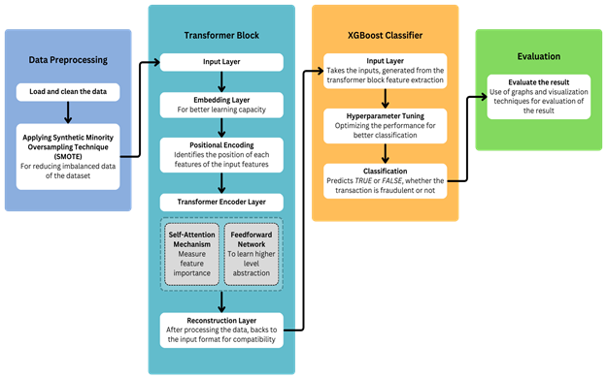

Fig. 1. Proposed Model Architecture

From the above architecture, at the very beginning, the data is being preprocessed. The data are loaded and cleaned in the data preprocessing block to get processed data. After that, the Synthetic Minority Oversampling Technique (SMOTE) has been used to make sure there is no imbalanced data. Imbalanced data can manipulate or hamper the model's accuracy and make the model unreliable. That’s why SMOTE is used in this case to make the minority data balanced and make the dataset reliable.
After processing, input data is sent to the transformer block. Transformers are known for their ability to solve complex scenarios and patterns. Transformer helps in feature extraction without complexing the algorithm. Moreover, transformers are lightweight, so they can be used in real-life cases like fraud in credit card transactions. Also, the transformer model can analyze and detect trends in time-series data, which gives extra advantages in the detection of anomalies in financial sectors like credit card fraud. In the transformer block:
- Input Layer: The input layer of the transformer block takes the preprocessed data generated by the data preprocessing block. Here all the data are cleaned and the imbalanced data are cleaned from the dataset.
- Embedding Layer: For better learning capacity, the embedding layer has been used in this case. The embedding layer helps the model to convert input features into high-dimensional data for better representation and better learning capacity.
- Positional Encoding: To know the information of each feature's position, positional encoding is used. Positional encoding ensures to learn the model about the order of each feature in the model dataset. As a result, the features remain in a sequential position.
- Transformer Encoder Layer: Self-attention and Feedforward network are used to make the model more accurate in the complex pattern analysis. For capturing the relationships between the features, how they react with each other is calculated in the self-attention process. After that, the feedforward network has been used for the higher-level abstraction.
- Reconstruction Layer: In the reconstruction layer, the modified data are reconstructed back to the original state of the data for compatibility. After that, the data is sent to the XGBoost classifier for classification purposes.
As a classification method, the XGBoost classifier is used in this paper. The XGBoost classifier is the most lightweight technique in terms of classification. The XGBoost classifier is also promising for structured data. Moreover, it also gives good accuracy for real-time applications. In this paper, XGBoost is used as a CNN-based classifier method to classify fraud.
- Input Layer: The input layer of the XGBoost classifier takes the Transformer Encoder's enhanced feature representation. This layer receives the feature metrics (X_train_transformed and X_test_transformed). It also responsible for the binary classification.
- Hyperparameter Tuning: This layer enhances the performance of XGBoost to produce better classification metrics. It also chooses the best model during the training phase, based on the F1 score.
- Classification: This is the final layer of the XGBoost classifier, which is responsible for showing the predicted result for fraudulent and real transactions.
The Transformer Encoder eliminates unnecessary complexity and concentrates only on the essential characteristics and patterns that are required to make the system more efficient and detect fraud in real-time transaction scenarios. The Transformer Encoder component is lightweight compared to full transformer models (BERT). Unlike sequential models like RNNs or LSTMs, the transformer’s self-attention mechanism processes all features at once parallelly, which reduces computation time. It also saves computational resources by minimizing the feature space provided to the classifier through the extraction of high-quality features. Additionally, for structured data, XGBoost works effectively. It iteratively increases classification accuracy with minimal overhead by using an enhancement strategy. Also, for real-time applications, it preserves computational efficiency.

Experimental Setup
The primary goal of this paper is to propose a hybrid model for credit card fraud detection using a combined deep learning model Transformer Encoder for feature extraction and a machine learning model XGBoost for classification. This approach focuses on ensuring higher accuracy in the minimum time working on imbalanced datasets.

DataSet Overview:
The dataset used in the research is the Credit Card Fraud Detection dataset, which is available on Kaggle and made by European cardholder's credit cards. The dataset includes time, amount and other transformed features of the transaction. The Time and Amount feature is standardized to scale with other features. The SMOTE (Synthetic Minority Over-sampling Technique) function is applied to oversample the minority class as the dataset is extremely unbalanced. The train_test_split function was then used to separate the whole dataset into 80% training and 20% testing groups.

Model Architecture and Algorithms
The paper implements a lightweight hybrid model with a Transformer Encoder and XGBoost Classifier.

1. Transformer Encoder Algorithm
The Transformer Encoder uses multiple layers to extract the important features from the dataset. At the start, it takes the preprocessed data from the dataset and maps the input features of the dataset in a high-dimensional space. Then in the mapped feature, the position of each feature is identified and the prioritized features are kept sequentially. The attention mechanism is applied to find out the relationships between features and recognize a list of patterns. To process the learned feature, the feedforward network captured the best pattern that matches fraud. Then, through the reconstruction layer, the final feature is processed into the previous input form, which is driven to the XGBoost model.

2. XGBoost Algorithm
XGBoost is a machine learning method that works with a decision tree, where each new tree corrects errors made by the previous tree. The XGBoost model takes input from the Transformer encoder and is optimized using GridSearchCV for hyperparameter tuning to select the best hyperparameters. The scale_pos_weight parameter is used to scale the weight of the positive class (fraudulent transactions) to address the imbalance. At last, the XGBoost classifier shows the predicted result of fraudulent transactions.

Training Setup
The system is implemented using Python, TensorFlow for the Transformer Encoder, and XGBoost for classification. For effective Transformer training, the training was carried out on a system with GPU acceleration. For tree-based learning tasks, scikit-learn with XGBoost uses the CPU, while TensorFlow uses the GPU for the Transformer Encoder.

Result Analysis and Discussion
Combining Transformer Encoder and XGBoost Classifier, the proposed hybrid model was evaluated on the European Credit Card dataset to perform in detecting fraudulent transactions. Feature extraction is applied to standardize the Time and Amount column to ensure proper scaling among all features. In the training data, the SMOTE function improved the balance between the minority and majority classes. To prevent biasness in the prediction of models, this is needed. Evaluation metrics focused on strong performance in fradulant class detection. The self-attention mechanism and positional encoding are applied by the Transformer Encoder to capture the relationship between columns in the dataset. The embedding layer extracted the complex features in the input and kept the sequential information. The XGBoost classifier applied GridSearchCV, which identified optimal parameters and improved the model’s classification accuracy.
The proposed model outperformed traditional models in handling imbalance data. The logistic regression models struggle with recall performance and random forest faces issues with imbalance class. But this hybrid model performs well and overcomes these obstacles due to its Transformer based feature selection and XGBoost classification method. Given the dataset’s imbalance class, PR AUC is used to measure the model's performance. The high score makes the model more effective.
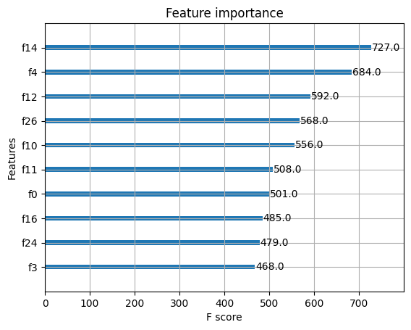
Fig. 2. Feature Importance Graph

Figure 2 represents the preferable features for fraud detection, which are obtained from the output from the XGBoost classifier. It shows that feature number 14 is the most used and important feature, which has an F score of 727. Other most used features for better accuracy in the system are f4, f12, f26 with Fscore of 684, 592, 568 and others.

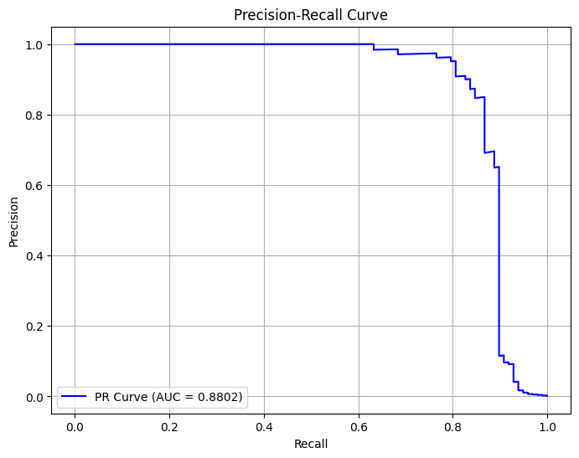
Fig. 3. Area Under the Precision-Recall Curve Graph

Figure 3 represents the precision-recall curve, which has an Area Under Curve (AUC) of 0.8802. The AUC curve plots the true positive rate against the false positive rate to show better accuracy.

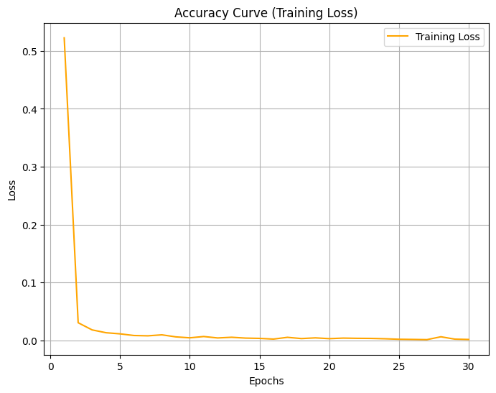
Fig. 4. Training Loss Graph

Figure 4 represents the training loss curve of the proposed Transformer Encoder model. Here 30 epochs were run to get the lowest loss and highest accuracy. At the beginning, the loss was 0.65, which gradually reduced to 0.000189 at the 30th epoch. The minimum loss of the model is 0.000189, which determines the accuracy is almost 0.999811.
By combining the advantages of XGBoost and Transformer Encoder, our model gets incredible accuracy and efficiency, making it highly applicable to the real world. Banking and financial institutions are the main targets, where fraud detection is challenging. So many people are involved in financial transactions every second. Our model can monitor and analyze vast amounts of data at a time in real-time. So it can be useful for payment gateways. Also, it can identify suspicious credit card transactions and unauthorized banking access and reduce false alarms. Online shopping is growing rapidly with problems of fraudulent transactions, return scams, fake accounts, etc. Both customers and e-commerce shops lose a lot of money from fraudulent transactions. Our model can be a safeguard for e-commerce and retail businesses. Pattern recognition can also be useful to cybersecurity for supply chain monitoring. Our model has the ability to learn and change its strategies by itself from finding relationships in input features. This adaptive nature makes it more reliable and useful in any sector of card transactions.
With the combination of Transformers and XGBoost, this model digs deep down to catch fraudulent activity precisely. This combinational approach makes our system quick to stop fraud before doing any damage. A large amount of manpower will not be required to manually check transaction reports because of the accuracy and efficiency of our system. Also for banking, healthcare, and e-commerce sites, this system is flexible enough to be used. This technique can be modified to deal with fraud wherever it occurs. Every company hasn’t access to massive servers or cutting-edge tech. This model is lightweight and can work with limited hardware. Pattern recognition can also be useful to cybersecurity for supply chain monitoring.

Conclusion
Fraud detection in the present day requires much more than just conventional techniques. It requires an important balance between accuracy, effectiveness, and flexibility. Fraud detection is a legitimate problem that has daily effects on both individuals and organizations. This study introduces a hybrid model that combines the efficient XGBoost classification with the transformer encoder's feature extraction and identification capabilities. This model achieves an impressive accuracy of 99.98% and a loss of 0.000189, proving its remarkable effectiveness against fraudulent transactions. This model outperformed the Credit Card Fraud Detection Dataset, so it may also work well on other datasets. Future work aims to introduce a unified fraud detection model that will be able to detect card and mobile transaction fraud at the same time. The future work will contain more effective algorithms to perform in all types of datasets. A model representing a powerful practical solution for detecting fraudulent activities in highly imbalanced datasets. This hybrid lightweight model can able to detect fraudulent transactions in real-time and protects both businesses and individuals.

References
- Femila Roseline, J.; Naidu, G.; Samuthira Pandi, V.; Alamelu alias Rajasree, S.; Mageswari, N. Autonomous credit card fraud detection using machine learning approach. Comput. Electr. Eng. 2022, 102, 108132.
- Alharbi, A.; Alshammari, M.; Okon, O.D.; Alabrah, A.; Rauf, H.T.; Alyami, H.; Meraj, T. A Novel text2IMG Mechanism of Credit Card Fraud Detection: A Deep Learning Approach. Electronics 2022, 11, 756.
- mineraltree (2015). 5 Advantages of Electronic Payments For Your Business. [online] MineralTree. Available at: https://www.mineraltree.com/blog/the-advantages-of-electronicpayments.
- TheGlobalEconomy.com. (2021). Percent people with credit cards by country, around the world. [online] Available at: https://www.theglobaleconomy.com/rankings/people_with_credit_cards.
- Statista. (n.d.). Value of payment card fraud worldwide 2027. [online] Available at: https://www.statista.com/statistics/1264329/value-fraudulent-card-transactions-worldwide.
- Pudjihartono, N.; Fadason, T.; Kempa-Liehr, A.W.; O’Sullivan, J.M. A Review of Feature Selection Methods for Machine Learning-Based Disease Risk Prediction. Front. Bioinform. 2022, 2, 927312.
- Bouaguel, W. A New Approach for Wrapper Feature Selection Using Genetic Algorithm for Big Data. In Intelligent and Evolutionary Systems; Springer: Cham, Switzerland, 2016; pp. 75–83.
- Hari Kishan Kondaveeti, Valli Kumari Vatsavayi, Srileakhana Mangapathi and Yasaswini, R.M. (2023). Lightweight Deep Learning. Advances in business information systems and analytics book series, [online] pp.242–259. doi:https://doi.org/10.4018/978-1-6684-8386-2.ch012.
- Sakharova, I., 2012, June. Payment card fraud: Challenges and solutions. In 2012 IEEE international conference on intelligence and security informatics (pp. 227-234). IEEE.
- Adewumi, A.O. and Akinyelu, A.A., 2017. A survey of machine-learning and nature-inspired based credit card fraud detection techniques. International Journal of System Assurance Engineering and Management, 8, pp.937-953.
- Randhawa, K., Loo, C.K., Seera, M., Lim, C.P. and Nandi, A.K., 2018. Credit card fraud detection using AdaBoost and majority voting. IEEE access, 6, pp.14277-14284.
- Karthik, V.S.S., Mishra, A. and Reddy, U.S., 2022. Credit card fraud detection by modelling behaviour pattern using hybrid ensemble model. Arabian Journal for Science and Engineering, 47(2), pp.1987-1997.
- Mienye, I.D. and Sun, Y., 2023. A machine learning method with hybrid feature selection for improved credit card fraud detection. Applied Sciences, 13(12), p.7254.
- Fu, K., Cheng, D., Tu, Y. and Zhang, L., 2016. Credit card fraud detection using convolutional neural networks. In Neural Information Processing: 23rd International Conference, ICONIP 2016, Kyoto, Japan, October 16–21, 2016, Proceedings, Part III 23 (pp. 483-490). Springer International Publishing.
- Saia, R. and Carta, S., 2017, July. Evaluating Credit Card Transactions in the Frequency Domain for a Proactive Fraud Detection Approach. In SECRYPT (pp. 335-342).
- Fiore, U., De Santis, A., Perla, F., Zanetti, P. and Palmieri, F., 2019. Using generative adversarial networks for improving classification effectiveness in credit card fraud detection. Information Sciences, 479, pp.448-455.
- Esenogho, E., Mienye, I.D., Swart, T.G., Aruleba, K. and Obaido, G., 2022. A neural network ensemble with feature engineering for improved credit card fraud detection. IEEE Access, 10, pp.16400-16407.
- El Kafhali, S., Tayebi, M. and Sulimani, H., 2024. An Optimized Deep Learning Approach for Detecting Fraudulent Transactions. Information, 15(4), p.227.
- Mienye, I.D. and Sun, Y., 2023. A deep learning ensemble with data resampling for credit card fraud detection. IEEE Access, 11, pp.30628-30638.
- AnalytixLabs (2024). A Complete Guide to Genetic Algorithm — Advantages, Limitations & More. [online] Medium. Available at: https://medium.com/@byanalytixlabs/a-complete-guide-to-genetic-algorithm-advantages-limitations-more-738e87427dbb.
- Hari Kishan Kondaveeti, Valli Kumari Vatsavayi, Srileakhana Mangapathi and Yasaswini, R.M. (2023). Lightweight Deep Learning. Advances in business information systems and analytics book series, [online] pp.242–259. doi:https://doi.org/10.4018/978-1-6684-8386-2.ch012.
- Kaggle (2018). Credit Card Fraud Detection. [online] www.kaggle.com. Available at: https://www.kaggle.com/datasets/mlg-ulb/creditcardfraud

